CyberFirst Adventurers

Sports
Introduction
There has been an increase in the popularity of the game Quidditch, made famous in the Harry Potter series of books. There are national regulatory bodies in both the UK and the USA who produce the rulebooks and train officials. Due to the rapid increase in funding owing to recognition by schools and universities for this niche competitive sport, many people are looking to create or join a local Quidditch team to compete in the newly formed Quidditch Premier League (QPL). Data analysts have been busy creating a dataset of statistics for a large number of players who are new to the game and are attempting to catch a manager’s eye.

As a manager, it is imperative to pick the best players possible, whilst also considering the players’ best position given their skillset.

Dataset
The statistics for each new player are provided in the form of an .xlsx file containing the following column headings:
Personal Stats:
• First Name
• Surname
• Gender
• Weight
• Height
• City
• Occupation

As well as a collection of Playing Stats (numerically out of 20 where appropriate), there are 200 records of player information provided.

This fictitious scenario is not licensed by, sponsored by or associated with Warner Bros., J.K. Rowling, or their affiliates. ‘Quidditch,’ ‘Harry Potter,’ and all related names, characters and indicia are trademarks of and © Warner Bros. – Harry Potter publishing rights © J.K. Rowling
Choosing your team
You have been chosen to be the manager of the latest team to join the QPL – the Cheltgardium Leviosas – and, as such, have to select your new team of seven members in accordance with the rules laid out by the US Quidditch organisation (shown below).
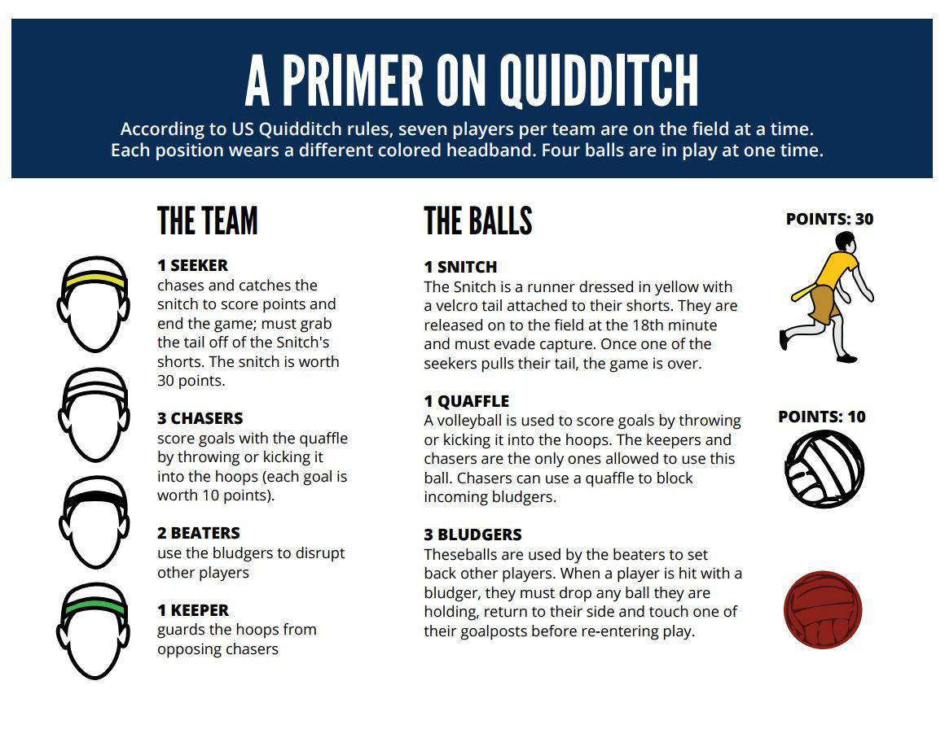
It is your task to use the statistics, data analytics, sorting and logical thinking to choose your team to include the best possible players. There are no substitutes required for your team, so only seven players need to be chosen and registered.
Players name
Seeker
Chaser
Chaser
Chaser
Beater
Beater
Keeper

