CyberFirst Schools/Colleges
Application Form (Northern Ireland)

© Crown Copyright 2019, The National Cyber Security Centre
Contents
Your contact details 4
Data Protection 4
Introduction 5
Application Guidance 5
Assessment 5
Scoring 6
Requirement 1 – (Pass/Fail) 9
Additional Guidance 9
Requirement 1 (Answer sheet 1 of 1) 10
Requirement 2 - (Rating 0-4) 12
Requirement 2 (Answer sheet 1 of 2) 13
Requirement 2 (Answer sheet 2 of 2) 14
Requirement 3 - (Rating 0-4) 15
Additional Guidance 15
Requirement 3 (Answer sheet 1 of 1)Requirement 4 - (Pass/Fail) 16
Additional Guidance 18
Requirement 4 (Answer sheet 1 of 2) 19
Requirement 4 (Answer sheet 2 of 2) 20
Requirement 5 - (Rating 0 to 4) 21
Additional Guidance 21
Requirement 5 (Answer sheet 1 of 1) 22
Requirement 6 - (Pass/Fail) 24
Additional Guidance 24
Requirement 6 (Answer sheet 1 of 1) 25
Requirement 7 - (Rating 0 to 4) 28
Additional Guidance 29
Requirement 7 (Answer sheet 1 of 2) 30
Requirement 7 (Answer sheet 2 of 2) 31
Requirement 8 - (Rating 0 to 4) 32
Additional Guidance 32
Requirement 8 (Answer sheet 1 of 2) 33
Requirement 8 (Answer sheet 2 of 2) 34
Requirement 9 - (Rating 0 to 4) 35
Additional Guidance 35
Requirement 9 (Answer sheet 1 of 2) 36
Requirement 9 (Answer sheet 2 of 2) 36
Requirement 10 - (Rating 0 to 4) 37
Additional Guidance 37
Requirement 10 (Answer sheet 1 of 1) 38

Please note: ALL sections need to be completed

Your contact details
Name of applicant: Example application
Name of School/College: Bronze Example School
School/College Address (inc postcode):
Contact Email: cfschools@ncsc.gov.uk
Contact Phone:

Additional Information
Number of students in school: X
Number of students who study computer science at, include gender split in %
GCSE: X
A level: X
How many teachers are teaching stem subjects? X
How many free school meals are provided? X

We want to thank Dalriada School for letting us use their gold application as an example.

Data Protection
We handle all data according to our requirements under the Data Protection Act 2018. Any data provided will be handled in accordance to the purposes it was requested, and you have certain rights regarding its ongoing use. For more information please see our Privacy notice (https://www.gchq.gov.uk/section/about-this-website/privacy)
Please mark the box with an X to confirm that you agree to any personal data submitted in this form being held and used in relation to CyberFirst activities.
At any time, you can rescind your permission. Please contact CyberFirst_Unsubscribe@ncsc.gov.uk
I agree ☒
Date: 11/12/2020

Introduction
Thank you for applying to be a CyberFirst School/College. In this application form you will find Sections 1-8 that require completion. To successfully complete this application, you will need to refer to the “CyberFirst Schools/Colleges call for applications” document. If you haven’t already done so, you can download a copy of the document at https://www.ncsc.gov.uk/cyberfirst/ . We recommend you read thoroughly through the document before attempting to complete this application. Any supporting documentation for each requirement should clearly identify which requirement it relates to and must be submitted separately to cfschools@ncsc.gov.uk. Please label the subject heading with your school/College name and your name.

Application Guidance
All sections of this application form must be completed and submitted, along with any additional supporting information to cfschools@ncsc.gov.uk by 22.00hrs on 11th December 2020.
Please complete the application, typing or writing your answers within the relevant pages marked ‘Answer Sheet’ using single spacing and using size 11/12 Calibri or Arial font.

Assessment
Applications within scope will be assessed by an assessment panel that will include representatives from government, industry and academia. Each application will be read and scored independently by a minimum of three members of the Assessment Panel. Panel members may go back to schools/colleges for clarification questions.

Scoring
At the Assessment Panel meeting, Panel members will present their scores and the rationale for their scores. In terms of providing evidence to meet the assessment criteria, each scored section of each application will be marked using the following scale:
Scoring Interval | Definition
0 | Fail - No response or no response capable of assessment has been submitted, or the response does not address the criteria of the requirement.
1 | Preliminary Fail - The response meets some but not a majority of the requirement and/or insufficient evidence is provided to substantiate the response. There are significant deficiencies in the response.
2 | Pass - The response meets the majority but not all of the requirement and there are minor deficiencies in how the application addresses the remaining criteria. For those parts of the requirement that are met, sufficient evidence to substantiate the response is provided.
3 | Exceeds expectations - The response meets the requirement in full and is supported by further evidence that substantiates the response. All of the criteria of the requirement are completed covered by the response.
4 | Outstanding - The response meets and exceeds the requirement. The response is backed up by substantial and convincing evidence.

Pass/Fail questions
Result | Definition
Fail | No response or no response capable of assessment has been submitted, or the response does not address the criteria of the requirement.
Pass | The requirement is met by the response.

The Panel’s decision is final. There is no maximum number of successful applications for CyberFirst Schools/Colleges. A successful application requires that each scored section must achieve a Pass or achieve a threshold score of 2.

Scoring against all levels
At the Assessment Panel each application will be assessed against each of the requirements outlined in the table below. Each application should address each section below.
ID | Requirements | Gold | Silver | Bronze | Scoring System
1 | Signed statement of support from the proposed CyberFirst school/college Principal and supporting core team.  (up to one side of A4 plus any supporting information) | ✓ | ✓ | ✓ | P/F
2 | Description of the proposed CyberFirst School/College cyber security education strategy  (up to two sides of A4 plus any supporting information) | ✓ | ✓ | Must show a plan | 0-4
3 | Must have a well-defined core team comprising specialist * staff and must be able to show that it works effectively, and has regular engagement.  (up to one side of A4 plus any supporting information) | ✓ | ✓ | Must show a plan | 0-4
4 | Proposed CyberFirst School must offer computing or equivalent at KS3, KS4 and KS5 (If it has a 6th form) or just KS3 and KS4 (if no 6th form). Proposed CyberFirst College must offer computing or equivalent at Level 2/Level 3.  (up to two sides of A4 plus any supporting information) | ✓ | Yes or show a plan | Show a plan | P/F
5 | Description of the proposed CyberFirst schools/colleges teaching CPD opportunities.  (up to one side of A4 plus any supporting information) | ✓ | ✓ | Show a plan | 0-4
6 | The proposed CyberFirst school must offer a minimum of x hours per week in KS3 computing and/or other cross curricular lessons. (requirement not applicable to proposed CyberFirst College applications)  (up to one side of A4 plus any supporting information) | 1.5 hours a week | 1 hour a week | A plan for how it will offer KS3 computing | P/F
7 | Description of the proposed CyberFirst school/college enrichment activities in Computing/Cyber Security at all Key Stages.  (up to two sides of A4 plus any supporting information) | 1.5 hours a week | 1-hour week | Not time bound – but much show evidence | 0-4
8 | Description of the proposed CyberFirst school primary school engagement in computing/cyber security. Description of the proposed CyberFirst College Secondary school engagement in computing/cyber security.  (up to two sides of A4 plus any supporting information) | ✓ | Must do or show a plan | Must do or show a plan | 0-4
9 | Description of the proposed CyberFirst School/College external engagement activities and plans in computing/cyber security.  (up to two sides of A4 plus any supporting information) | Current and future plans | Current and future plans | Future plans | 0-4
10 | Description of how and what the proposed CyberFirst School/College participates in or advertises CyberFirst activities or equivalent.  (up to one side of A4 plus any supporting information) | ✓ | ✓ | ✓ | 0-4

Requirement 1 – (Pass/Fail)
The proposed CyberFirst School/College must provide a signed Statement of Support from the Principal showing support for the school/college’s application to be recognised as a CyberFirst School/College. By way of example, it is suggested that the School/College’s senior management use the Statement of Support to demonstrate its continued commitment to:
- Computing/Computational thinking/Cyber security in the School/College’s future strategy
- Investment, either financial or time, in the area of computing, computational thinking and/or cyber security
- Supporting proposed external engagement and enrichment activities
- Working to improve cyber security awareness and behaviours for pupils and staff across the school/college
- Maintaining its cyber security strategy
In addition, Gold applicants must provide the additional two points below:
- School/College has taken appropriate steps to protect itself from cyber incidents e.g. by demonstrating 10 steps, cyber essentials (https://www.ncsc.gov.uk/cyberessentials/overview)
- Appointment of a CyberFirst School/College’s lead within the School/College who will be the main point of contact for NCSC.
☐ Gold - The proposed CyberFirst School/College must provide all the points from 1-7

☐ Silver - The proposed CyberFirst School/College must provide points 1 – 5

☒ Bronze - The proposed CyberFirst School/College must provide points 1 – 5

Additional Guidance

Please provide a response to each bullet. We will be seeking evidence against all points

Requirement 1 (Answer sheet 1 of 1)
Below is a signed statement of support from the Principal showing support for Dalriada school’s application to be recognised as a CyberFirst School.
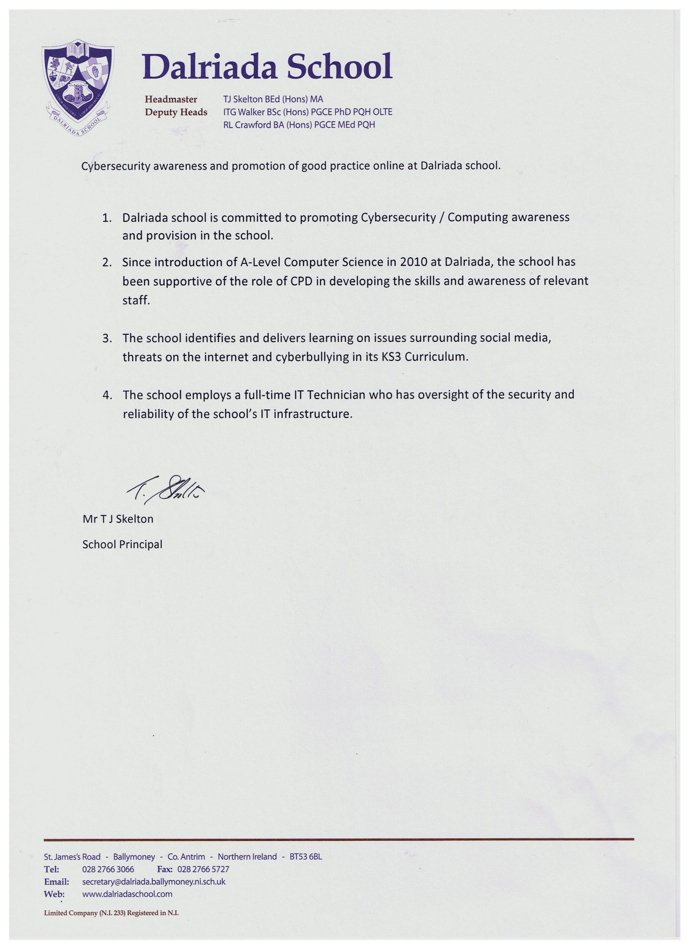

Requirement 2 - (Rating 0-4)
The proposed CyberFirst School/college must have a strategy/plan for how it will consolidate and develop cyber security education. By way of example, this might include plans for:
- Growth in staff numbers and/or expertise
- Continuing and/or growing coding and computational thinking from Key Stage 3-A/AS Level and seeing a steady increase in numbers.
- Further promotion of computing/computational thinking/cyber security across the school/college
- Continued and/or deepening engagement with industry and other schools/colleges
- Keeping up to date with computing/computational thinking/cyber security education, for example, actively attending courses on an annual basis
- Demonstrate how it is integrating cyber and cyber security into a range of differing subject across the curriculum.
- Engagement with related teacher learning and learner support activities in Northern Ireland, for example:
  - Whether the proposed CyberFirst School/College is engaging in any activities such as those offered through Code Club
  - Whether the proposed CyberFirst School/College is taking part in any initiatives such as CCEA online coding courses, Project Quantum.
  - Whether the proposed CyberFirst School/College is taking part in any outreach activities
  - Whether the proposed CyberFirst School/College is taking part in any related activities or courses with local software/IT companies (e.g. All State, Kainos, PwC, BT)
  - Whether the proposed CyberFirst School/College is undertaking work with local universities, such as Queens University, Belfast.

☐ Gold - The proposed CyberFirst School/College must have a strategy/plan for how it will consolidate and develop cyber security education.

☐ Silver - The proposed CyberFirst School/College must have a strategy/plan for aspiring to be a CyberFirst GOLD School/College.
☒ Bronze - The proposed CyberFirst School/College must have a strategy/plan for aspiring to be a CyberFirst SILVER/GOLD School/College.

Requirement 2 (Answer sheet 1 of 2)
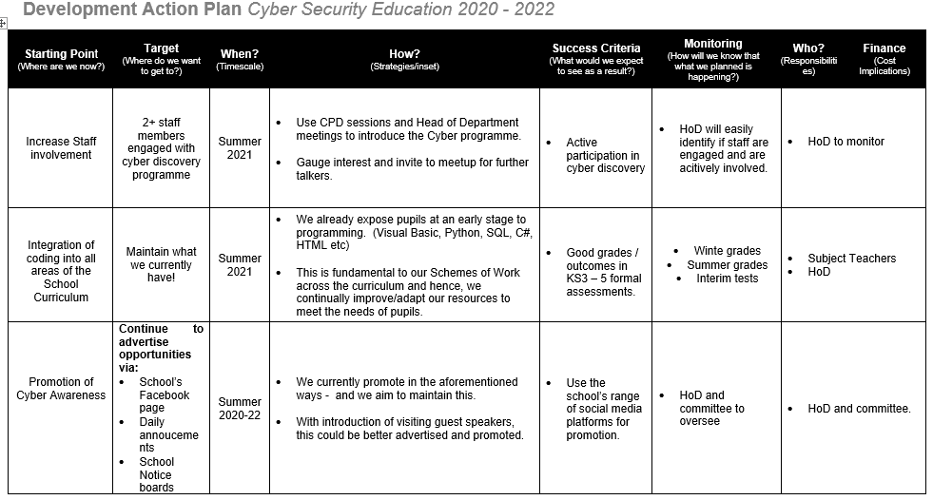

Requirement 2 (Answer sheet 2 of 2)

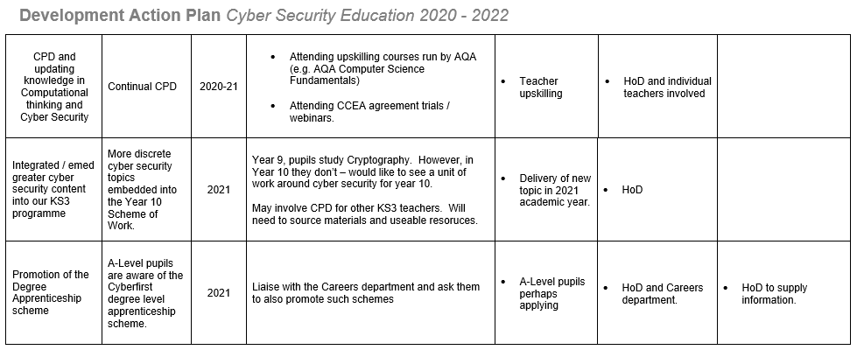

Requirement 3 - (Rating 0-4)
The proposed CyberFirst School/College must have a well-defined core team comprising specialist* staff and must be able to show that it works effectively, and has regular engagement with:
- Staff responsible for communication and outreach
- Staff responsible for diversity and inclusion (e.g. Shared Education)
- Staff from across the Areas of Learning
- Staff with responsibilities for the computing/computational thinking and communications infrastructure at the school/college (e.g. ICT Technician, C2k Manager in school/college supported by the EA C2k team)

☐ Gold - The proposed CyberFirst School/college must have a well-defined core team comprising specialist* staff and must be able to show that it works effectively

☐ Silver - The proposed CyberFirst School/College must have a well-defined core team comprising specialist* staff and must be able to show that it works effectively
☒ Bronze - The proposed CyberFirst School/College must have a proposed plan defining the future core team comprising specialist* staff

Additional Guidance
Specialist is someone whose main curriculum area is computing
It should be noted that we are not looking for evidence of a core team meeting as one, more how the school/college operate as a team to meet these criteria.
Please take care to clarify in your input what activity is current and what is proposed/planned.

Requirement 3 (Answer sheet 1 of 1)

The following staff make up the core team:

Teacher Name 1

Head of IT & Computer Science

Teacher Name 2

Vice Principal

Teacher Name 3

Head of Sixth Form

Teacher Name 4

Teacher of IT & Computer Science & Geography

Teacher Name 5

C2K Manager and IT Technician.

Roles are identified below:
Name | Responsibility
X | Communication & Outreach: Promotes STEM competitions and enrichment programmes available to pupils. For example, posters and flyers regarding Cyber Discovery competition and holding lunch time meetings for those pupils interested and involved.  Shared Education: Is a member of a Shared Education committee that enables Shared Education events to take place between pupils from local schools, from both Protestant and Catholic backgrounds.
X | Teacher of Technology & Design & Computer Science
X | Teacher of RE & KS3 IT.
X | Teacher of KS3 IT/Computing and Geography.
X | Managing school’s legacy network  C2K Manager

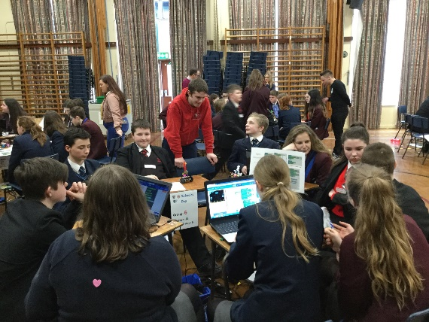
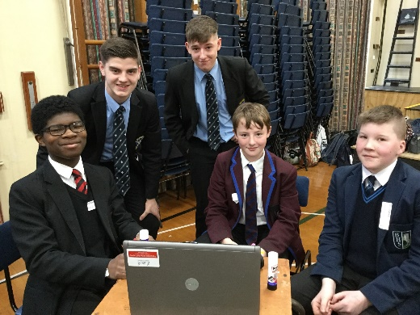
Evidence of the team working effectively can be demonstrated through the collaborative efforts in hosting a Robotics Workshop day for the local learning community (involving 2 other schools) The day focussed on problem solving tasks. It involved lots of preparation, setting up networks, designing tasks, transport arrangements and event day promotion.

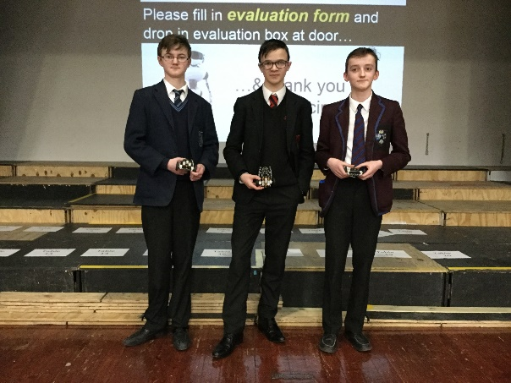

Requirement 4 - (Pass/Fail)
☐ Gold - The proposed CyberFirst School must offer Computing/Digital Skills at KS3, Digital Technology (Programming) at GCSE or equivalent as well as A level in Digital Technology/Software Systems Development (if school has a 6th Form) or equivalent. The proposed CyberFirst College must offer Computer Science or equivalent at Level 2/Level 3.
☐ Silver – The proposed CyberFirst School must offer Computing/Digital Skills at KS3, Digital Technology (Programming) at GCSE or equivalent as well as A level or equivalent in Digital Technology/Software Systems Development (if school has a 6th Form) or have a plan to offer such. The proposed CyberFirst College must offer Computer Science or equivalent at Level 2/Level 3 or have a plan to offer such.
☒ Bronze - The proposed CyberFirst School must offer additional Computing/Computational thinking/Cyber security enrichment activities in Key Stage 3 for at least one hour a week and have a plan to offer GCSE Digital Technology (Programming) and A-level (if school has a 6th form) . The proposed CyberFirst College must have a plan to offer Computer Science or equivalent at Level 2/Level 3.

Additional Guidance
Please provide school/college timetable or the school/college’s curriculum time allocation as evidence. To note that all examination boards are accepted.
Please take care to clarify in your input what activity is current and what is proposed/planned.

Requirement 4 (Answer sheet 1 of 2)

Current Key Stage 3 provision:
- In Northern Ireland, teaching of ICT/Computing as a discrete subject is not compulsory. In fact, a large number of schools in the province teach ICT in a cross-curricular capacity and have no time-tabled classes for this subject.

At Dalriada, the approach is different. For over 15 years, pupils in Key Stage 3 get weekly lessons in IT/Computing. The amount of time is as follows:
  - Year 8 (first year): each pupil gets 70 mins per week.
  - Year 9: each pupil gets 35 mins per week.
  - Year 10: each pupil gets 35 mins per week
The IT/Computing department regularly revise and update the content of what is taught. In relation to Cybersecurity education at KS3, the following provisions are made:
- Year 8: Pupils study Internet Safety for several weeks looking at:
  - Phishing
  - Cyberbullying
  - Click-bait
  - Netiquette
  - Passwords – weak vs strong
  - Trolling
- Year 9:
  - Cryptography: Study of Caesar Cipher, Rail Fence, Matrix, Enigma & Alan Turing
  - Python Coding: introduction to text-based programming language looking at Sequence and Selection statements.
- Year 10:
  - HMTL: pupils develop their own web pages solely using HTML
  - Embedded programming: Pupils learn to use Microbit and Bit:Bot (a robot that the microbits slots into) and code it using Python to complete several challenges.
  - Prototyping: mobile app development using Marvel App design.

Current Key Stage 4 provision:
- AQA GCSE Computer Science
- CCEA GCSE Digital Technology
Both of these learning pathways offered to all pupils have direct assessment in knowledge of cybersecurity measures.

Current Key Stage 5 provision:
- AQA A Level Computer Science
- CCEA A Level Digital Technology

Requirement 4 (Answer sheet 2 of 2)

Requirement 5 - (Rating 0 to 4)
The proposed CyberFirst School/College must support and provide time for teacher’s professional learning in computing, by way of example regional/national professional learning opportunities, cluster activities or qualifications.

Requirement 5 – (Score 0-4)
☐ Gold - The proposed CyberFirst School/College must provide current evidence on supporting the teachers professional learning in computing
☐ Silver - The proposed CyberFirst School/College must provide current evidence on supporting the teachers professional learning in computing
☒ Bronze - The proposed CyberFirst School/College must show aspirational plans to support teachers professional learning in computing

Additional Guidance
Please provide examples of professional learning attended in the last 2 years.
Please take care to clarify in your input what activity is current and what is proposed/planned.

Requirement 5 (Answer sheet 1 of 1)
CPD opportunities have been afforded to the staff and below is some evidence of such:
- X – AQA CPD – Computer Science Fundamental Skills course. (See screen shot below)
(picture of certificate of teacher X)
- X – school sent staff member to the European Space Agency in Redu, Belgium for a 3-4 residential workshop on problem-solving and working with robotics. See certificate of attendance below.
(picture of certificate)

Other CPD opportunities which are on a more regular basis would Standardisation events. The school faithfully opens up the opportunity for members of staff to attend these. Within the IT/Computing department, the standardisation events attended include:
- GCSE Agreement trials for Digital Technology
- A Level Agreement trials for Digital Technology
- Standardisation events for A Level Computer Science take place online and are done online in teacher’s own time.

Requirement 6 - (Pass/Fail)
☐ Gold - The proposed CyberFirst School must offer a minimum of 1.5 hours per week in Key Stage 3 computer science/digital skills.

☐ Silver - The proposed CyberFirst School must offer a minimum of 1 hour per week at KS3 computing/digital skills or other cross curricular lessons.
☒ Bronze - The proposed CyberFirst School must offer a plan for how it will offer KS3 computing/digital skills or other cross curricular lessons.

Additional Guidance
Please note this requirement is not applicable to Cyberfirst College applications.
Please provide example of school timetabling or evidence as to how computing/cyber security is covered in other lessons.
Please take care to clarify in your input what activity is current and what is proposed/planned.

Requirement 6 (Answer sheet 1 of 1)
At Dalriada, the approach is different. For over 15 years, pupils in Key Stage 3 get weekly lessons in IT/Computing. The amount of time is as follows:
  - Year 8 (first year): each pupil gets 70 mins per week.
  - Year 9: each pupil gets 35 mins per week.
  - Year 10: each pupil gets 35 mins per week

Below are extracts from Timetables for pupils in each year group.

Year 8 allocation of KS3 IT/Computing:
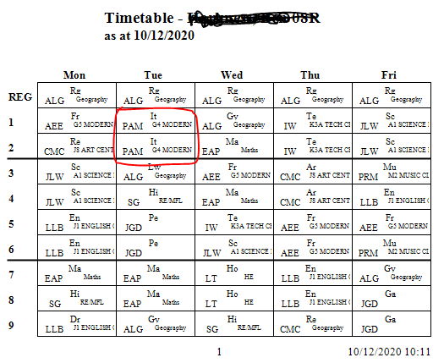

Year 9 allocation of KS3 IT/Computing:

:
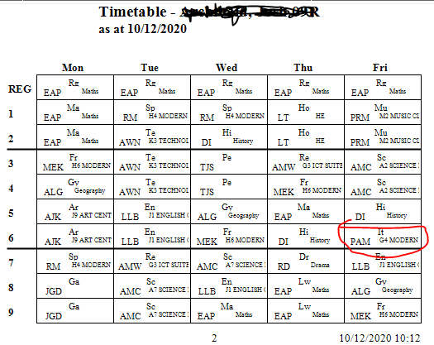

Year 10: allocation of KS3 IT/Computing:
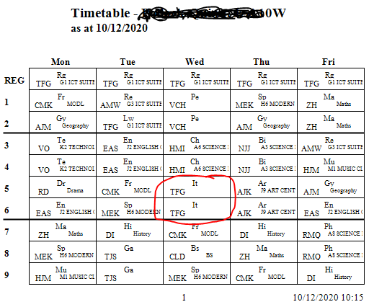

GCSE AQA Computer Science Timetable (140 mins per week)
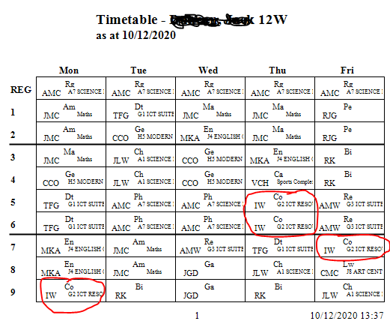

A Level AQA Computer Science Timetable (280 mins per week)
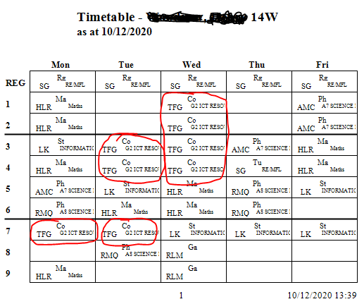

Requirement 7 - (Rating 0 to 4)
The proposed CyberFirst School/College must offer additional Computer science/Computational thinking/ Cyber security/digital skills enrichment activities in all Key Stages they provide provision for
☐ Gold - The proposed CyberFirst School/College must offer additional Computer science/Computational thinking/Cyber security/digital skills enrichment activities in all Key stages they provide provision for, for at least 1.5 hours per week
☐ Silver - The proposed CyberFirst School/College must offer additional Computer science/Computational thinking/Cyber security/digital skills enrichment activities in all Key Stages they provide provision for, for at least 1 hour per week
☒ Bronze - The proposed CyberFirst School/College must show aspirational plans on offering additional Computer science/Computational thinking/Cyber security/digital skills enrichment activities in in all Key Stages they provide provision for

Additional Guidance
Please provide examples of professional learning attended in the last year.
Please take care to clarify in your input what activity is current and what is proposed/planned.

Requirement 7 (Answer sheet 1 of 2)

Current:
The school has a Robotics club which is the main platform from which the school competes in STEM competitions. The Robotics club meets weekly, Tuesdays and Thursdays during lunchtimes for a period of 25-30 minutes. The club is open to ALL pupils of all Key Stages, so we typically have junior pupils working alongside more senior pupils.
Sixth formers act as mentors to the junior pupils whilst the Head of IT/Computing acts in a facilitating capacity.
Typical activities include:
- Yearly – members of the Robotics club alongside a Shared Education team, compete in the First Lego League competition.
- Yearly – our pupils compete in a Belfast-based Digital DNA competition. This invites pupils to develop a prototype for a Mobile App. For the last two years, we have won it! Our (twice) prize was an all-expenses paid trip to Silicon Valley, California. Year 2018 our pupils developed an App to help people with dementia. Year 2019 our pupils developed an App to help combat loneliness amongst the Aged population. See images below.

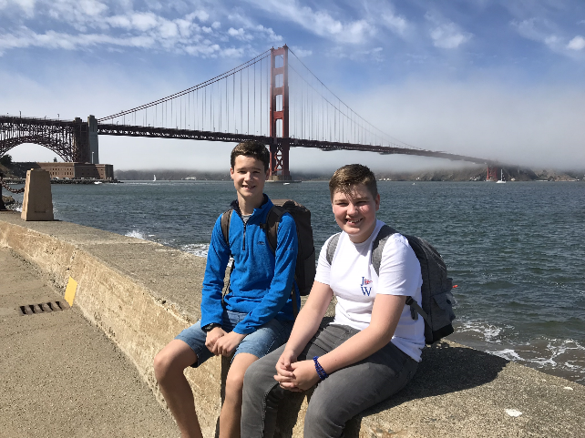

- Cyber Discovery – last year we entered this competition, with several of our pupils moving past the preliminary rounds. One of our Robotics Club leaders (Ross Anderson) has since been to the Cyber Futures residential in England. He has helped mentor some of the junior pupils as they try the cyber discovery challenges.

Requirement 7 (Answer sheet 2 of 2)

Requirement 8 - (Rating 0 to 4)
☐ Gold - The proposed CyberFirst School must be supporting and/or providing computing/computational thinking/cyber security/digital skills education in primary settings. The proposed CyberFirst College must be supporting and/or providing computing/computational thinking/cyber security/digital skills education in secondary settings.

☐ Silver - The proposed CyberFirst School must be or have a plan on how it will support and/or provide computing/computational thinking/cyber security/digital skills education in primary settings. The proposed CyberFirst College must be or have a plan on how it will support and/or provide computing/computational thinking/cyber security/digital skills education in secondary settings.

☒ Bronze - The proposed CyberFirst School must have a plan on how it will support the provision of computing/computational thinking/cyber security/digital skills education in primary settings. The proposed CyberFirst College must have a plan on how it will support the provision of computing/computational thinking/cyber security/digital skills education in secondary settings.

Additional Guidance
This can include inviting primary/secondary school children to join in clubs and not necessarily visiting primary/secondary schools.
Please take care to clarify in your input what activity is current and what is proposed/planned.

Requirement 8 (Answer sheet 1 of 2)
Current: There is no direct engagement with Primary schools.
Proposed: It is the intent of the Shared Education committee here that we would engage with local Primary schools, particularly Primary 7 pupils. The programme for engagement would be ‘IT Ambassadors’ where small groups of junior pupils from a mix of local Secondary schools, would go out to Primary schools and do some coding workshops e.g. Microbit, BitBot (with Microbit), Scratch, Lego Mindstorm Robotics. The benefits are twofold:
- Primary 7 children get a unique experience of being led/taught by secondary pupils who are passionate about coding
- Junior secondary pupils have the enriching experience of delivering a lesson(s) on a topic that they really enjoy to enthusiastic P7 children.

Requirement 8 (Answer sheet 2 of 2)

Requirement 9 - (Rating 0 to 4)
The proposed CyberFirst School/College must describe the school/college’s external engagement to date and future plans. For example, this might cover:
External engagement activities with industry, academia, local schools/college’s and how these add value to its computing / computational thinking / cyber security and digital skills education programme.
Outreach activities with the wider community and key outcomes to date, for example:
  - With schools/colleges, teachers, governors, under-represented groups, community groups and the like
  - Covering cyber security as well as basic cyber awareness
  - Providing support to other teachers with the teaching of computing / computational thinking and cyber awareness, not necessarily as part of a dedicated computing class
  - Track record of promoting teaching of computing with schools locally/regionally and leading professional learning for teachers
  - Track record of participating as part of regional/national professional learning programmes and establishing partnerships of organisations and individuals.
☐ Gold - The proposed CyberFirst School/College must describe the school/college’s external engagement to date and future plans
☐ Silver - The proposed CyberFirst School/College must describe the school/college’s external engagement to date and future plans
☒ Bronze - The proposed CyberFirst School/College must describe the school/college’s future plans for external engagement.

Additional Guidance
Please take care to clarify in your input what activity is current and what is proposed/planned.

Requirement 9 (Answer sheet 1 of 2)
Currently:
- We have no current outreach to our local community in terms of cyber security awareness.
- We have no external speakers coming in to our school addressing Cyber Security awareness.

Proposed/Planned:
- We will be inviting an external speaker to come and talk to our sixth form about the educational/career pathways that the Cyberfirst programme affords.

See below email correspondence with Maureen Heaney as we look for a visiting speaker to come to our school (25 Nov 2020)02020489r p7;i

Requirement 9 (Answer sheet 2 of 2)

Requirement 10 - (Rating 0 to 4)
The proposed CyberFirst School/College must participate in/advertise CyberFirst opportunities.
☐ Gold - The proposed CyberFirst School/College must participate in/advertise CyberFirst opportunities.
☐ Silver - The proposed CyberFirst School/College must participate in/advertise CyberFirst opportunities.
☒ Bronze - The proposed CyberFirst School/College must participate in/advertise or have aspirational plans for CyberFirst opportunities.

Additional Guidance
This can cover any CyberFirst/Cyber Discovery event. Please provide examples of what your school/college has taken part in.
Please take care to clarify in your input what activity is current and what is proposed/planned.

Requirement 10 (Answer sheet 1 of 1)

Current:
- Pupils have been actively engaged in Cyber discovery competition – some having completed the initial preliminary rounds.
- One our pupils (Ross Anderson) has been to the residential Cyber First Futures programme Monday 8th – Friday 12th July 2019.
- The IT & Computing department regularly promote and advertise STEM competitions, with Cyber Discovery certainly being one of them. Pupils are asked to come to classroom where past participants and teacher (HoD) introduce the challenges and invite those to engage.
- In the past, a couple of years back, a group of pupils from the A-Level computer science class participated in Cyber Centurion competition (which turned out to be a bit of a nightmare getting the IT infrastructure in place to compete)
- Not recently, but we have taken part in Bebras competition (problem-solving), PA Consulting Raspberry Pi competition and ‘Big Bang’ competition (where we won our category)

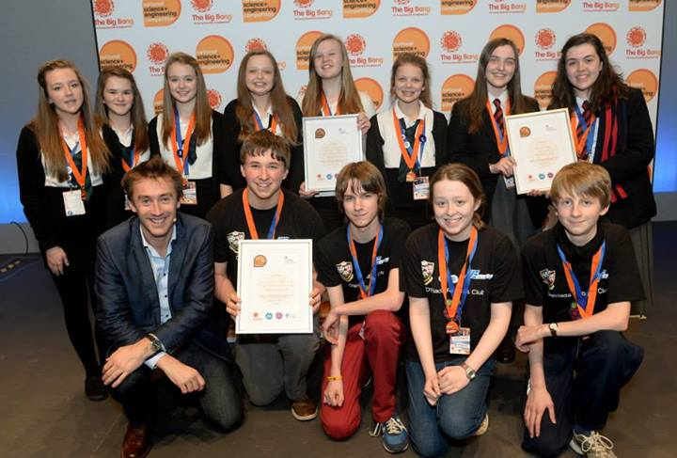

Big Bang Competition
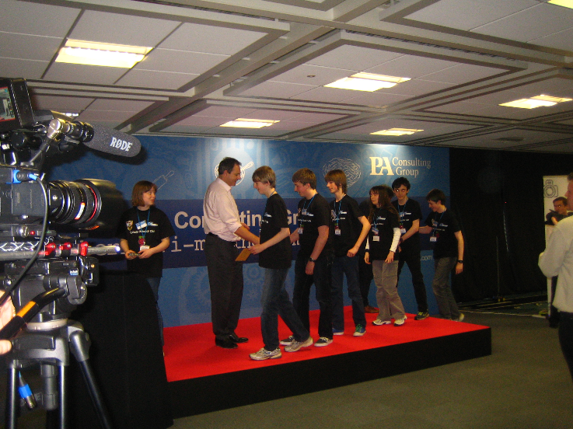
PA Consulting Raspberry Pi competition winners

Proposed/planned:
- Our plan is to increase the number of pupils engaged in the Cyber discovery competition. Many pupils enjoy the online activities and our intention would be to make this a regular lunchtime fixture during our Robotics Club meetings.

